Jenkins Server Setup
- Launching EC2 instance on Public Subnet
instance-name - JenkinsServer
ami- ubuntu 22.04
instance -type -t2.medium
keypair - chatapp.pem
vpc - ShaneVPC
subnet- PublicSubnetA
Enable auto assign IP
security-group Jenkins-sg-pubsub

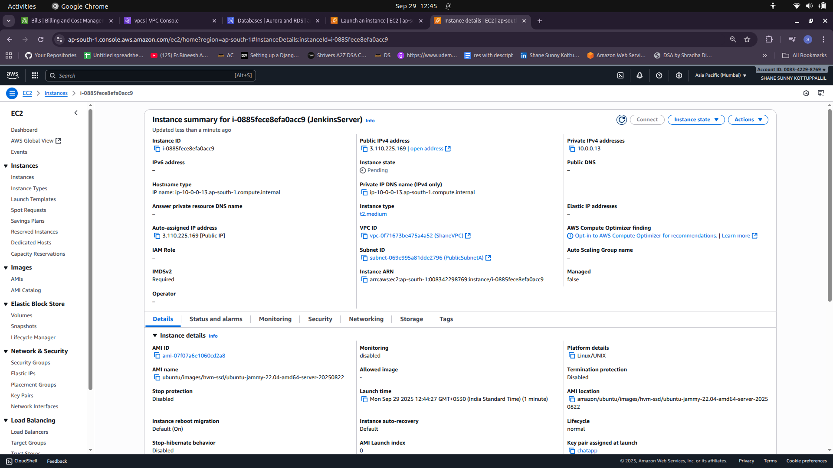

- Create and Associate Elastic IP to Jenkins Server (instance) for setting up Jenkins URL
- SSH to instance
- Update system
sudo apt update -y & sudo apt upgrade -y
- Install Java (Jenkins dependency)
sudo apt install -y openjdk-17-jdk
- Add Jenkins Repo and Install
curl -fsSL https://pkg.jenkins.io/debian/jenkins.io-2023.key | sudo tee \
/usr/share/keyrings/jenkins-keyring.asc > /dev/null

echo deb [signed-by=/usr/share/keyrings/jenkins-keyring.asc] \
https://pkg.jenkins.io/debian binary/ | sudo tee \
/etc/apt/sources.list.d/jenkins.list > /dev/null

- Update and Install Jenkins
sudo apt update -y
sudo apt install -y jenkins

- Start and Enable Jenkins Service
sudo systemctl start jenkins
sudo systemctl enable jenkins

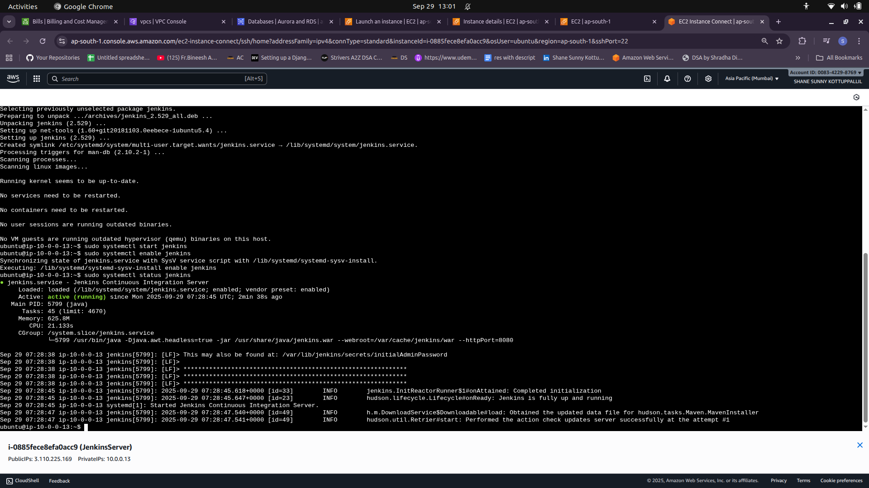

- Access Jenkins UI
http://15.206.177.73:8080 (Elastic IP)
Initial admin password: sudo cat /var/lib/jenkins/secrets/initialAdminPassword

- Install Suggested Plugins and Setup First Admin User
username - shanessk
password -
gmail - shanesunnyssk@gmail.com
Full Name - Shane Sunny Kottuppallil

